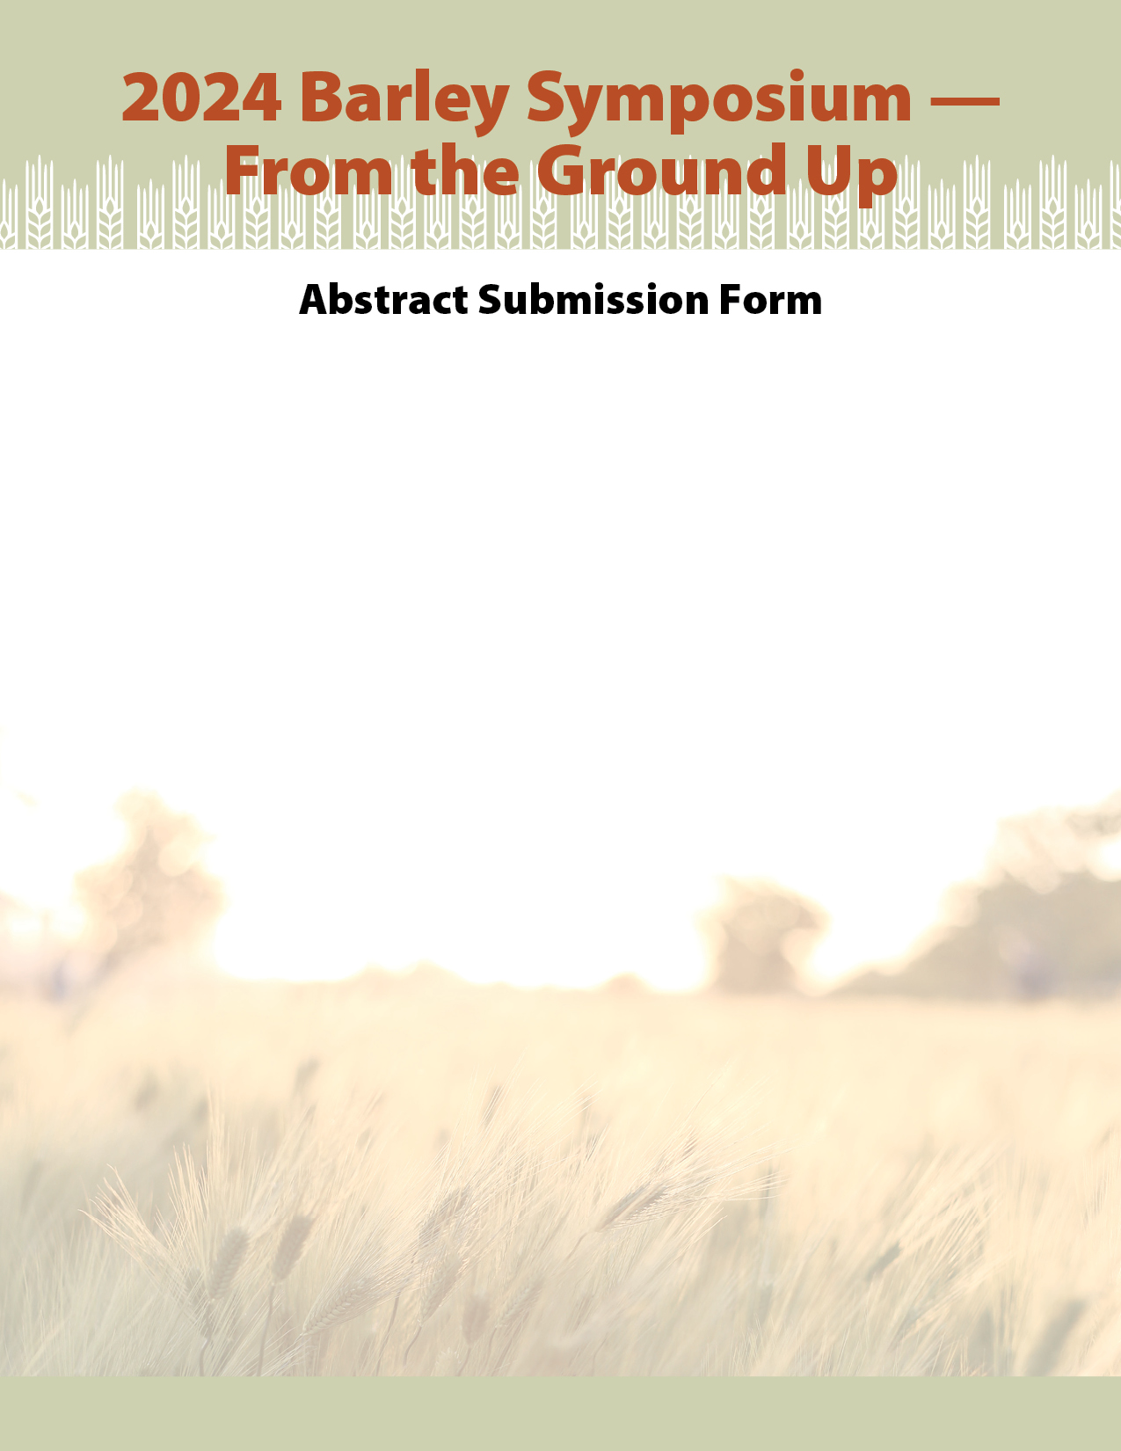
Canadian Barley Research Coalition (CBRC) - Student Travel Grant -

Students – CBRC is offering successful applicant(s) a grant to cover expenses to attend the 2024 Barley Symposium and Prairie Grain Development Committee Conferences in February 2024 in Saskatoon, SK.
This grant is intended to support students in attending conferences that enhance their educational opportunities outside of the classroom. Grants can cover any eligible expenses to a maximum of $2,000/person. Eligible expenses include conference registration fees, accommodations and travel costs (receipts will be required).
The deadline for application is January 31, 2024. Please submit your application to slagasse@barleyresearch.ca

Name:

Institution:

Are you presenting a poster at the Barley Symposium (*not required):

Describe your research project and how it will advance the barley industry (M.Sc. or PhD.) (maximum 400 words):

Describe how you will benefit from attending the Barley Symposium and Prairie Grain Development Committee Conferences (maximum 200 words):

Please attach your CV to this application.

