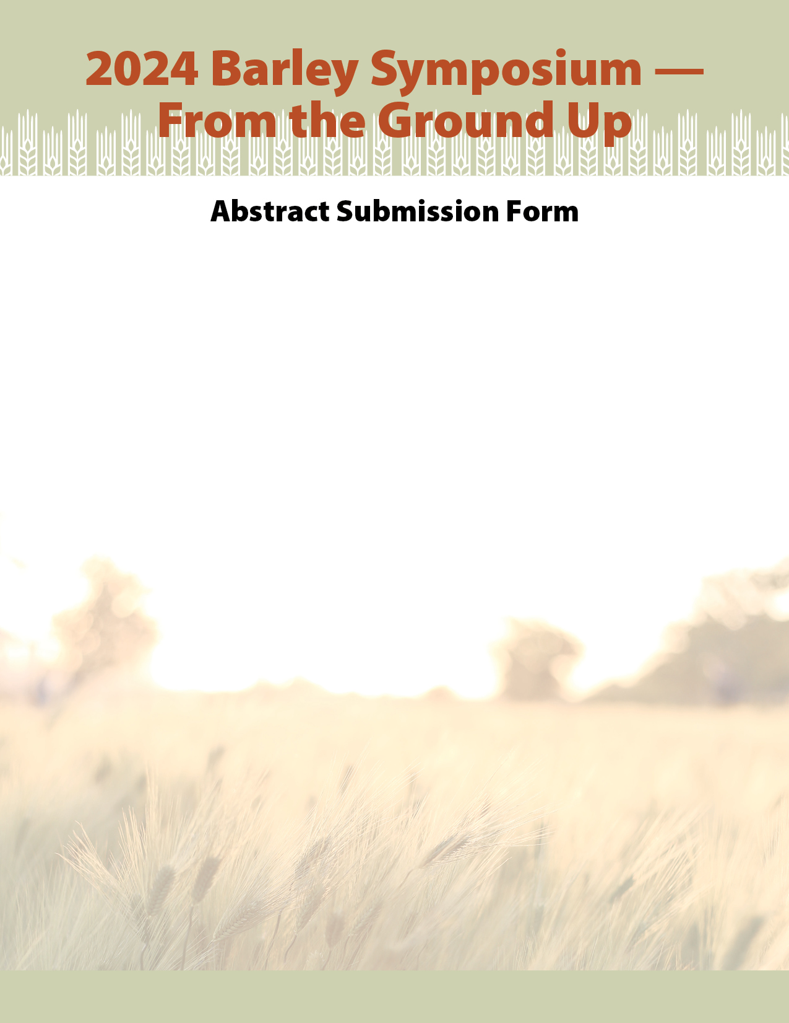

I am a: ☐ Graduate Student ☐ Post-doc researcher ☐ Professor/Scientist ☐ Research Assistant/Tech ☐ Other

I would like my abstract to be considered for a:
☐ Poster presentation
☐ Oral presentation in session(s) (check all that apply):
☐ 1: Emerging Biotic Threats
☐ 2: Advances in established biotic threat knowledge and management
☐ 3: New technology to advance variety development and agronomy
☐ 4: Progress in variety development and agronomy
☐ 5: Policy, international trade and economics of production
☐ 6: Barley fit for purpose – quality, feed, food, malt and other end-uses
I would like to be considered for a Student/Post-doc Oral/Poster Presentation Competition:
☐ Yes ☐ No
I would like to publish my abstract in the Canadian Journal of Plant Science (CJPS), if that becomes an option
☐ Yes ☐ No
If you are not selected for an oral presentation, would you be interested in the poster session.
☐ Yes ☐ No

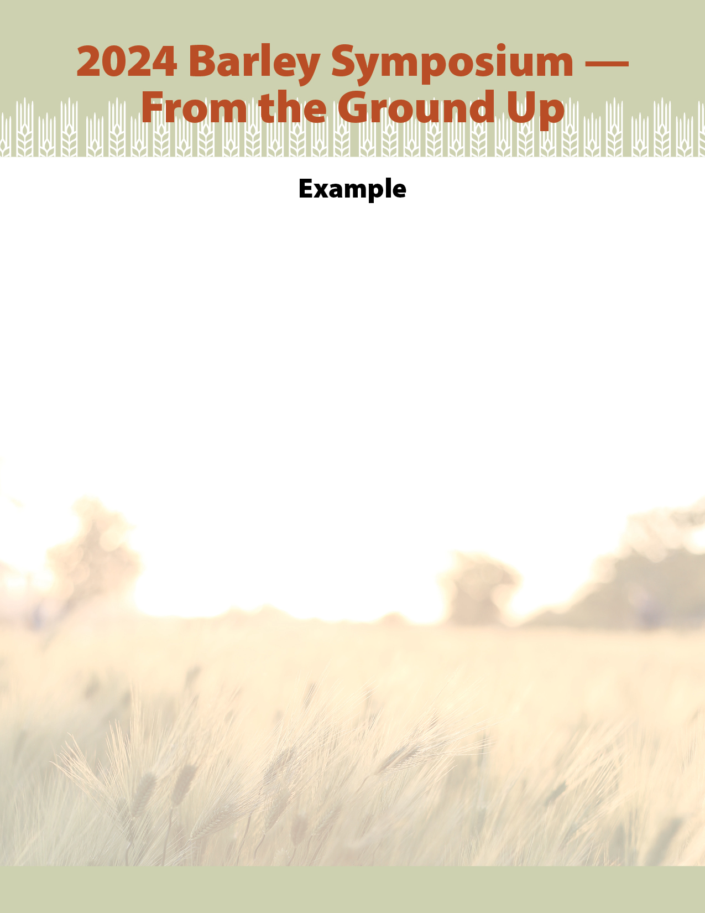

THIS IS THE TITLE OF MY PRESENTATION
John Smith¹, Jane Doe² and Eve Adam¹

¹Ottawa Research and Development Centre, Agriculture and Agri-Food Canada, 960 Carling Avenue, Ottawa, ON, Canada, K1A 0C6
²Crop Development Centre, University of Saskatchewan, College of Agriculture and Bioresources, 51 Campus Drive, Saskatoon, SK, Canada, S7N 5A8

Correspondence to: xxx@gmail.com

This is the body of your abstract which should not exceed 400 words. This is the template format for the Barley Symposium – From the Ground Up abstract submission. You should use Arial 10 point font throughout. The title should be capitalized and bold. The presenting author(s) should be underlined. Single line spacing should be used.

